**Human Biology**

**ATAR Unit 3**

**Test 1**

**Scientific Method, Endocrine and Nervous Systems**

|  |  |  |
| --- | --- | --- |
| Part A:  Multiple Choice | 30 marks |  |
| Part B:  Vocabulary | 10 marks |  |
| Part C:  Short Answer | 55 marks |  |
| Part D:  Extended Answer | 10 marks |  |
| Total: | 105 marks |  |

**Part A: Multiple Choice**

**Mark your answers to Questions 1-30 on the separate multiple choice   
answer sheet using a 2B, B or HB pencil. 30 marks**

Select the correct alternative in each of the following questions.

1. The correct term for nerve cells is:
   1. Epithelium.
   2. Connective.
   3. Neurons.
   4. Dendrites.
2. Stimulation of the parasympathetic nervous system would cause:
   1. the heart rate to increase.
   2. the pupils of the eyes to dilate.
   3. stimulation of the digestive system.
   4. the breathing rate to increase.
3. A hypothesis may be accepted by the scientific community if the:
   1. sample size tested is over 50% of the total population.
   2. data collected indicates a significant difference between the experiment and the control.
   3. data collected in the first trial supports the hypothesis.
   4. experiment is conducted by others and similar results are obtained each time this is done.
4. Which of the following hormones is NOT secreted by the anterior pituitary lobe?
   1. ACTH.
   2. Prolactin.
   3. TSH.
   4. ADH.
5. The cerebellum is concerned with:
   1. balance, coordination of motion and muscle tone.
   2. coordination of impulses between the cortex of the brain and the hypothalamus.
   3. sleep and emotion.
   4. voluntary control of respiration.

.

1. “Enzyme amplification” refers to:
   1. the effect a hormone has in increasing the total number of molecules of a particular enzyme.
   2. the reduction in the activation energy of a specific chemical reaction.
   3. the effect an enzyme has in increasing the rate of a reaction.
   4. the rapid rate that a product is formed in an enzyme controlled reaction.
2. Hormones work by:
   1. acting as enzymes within target cells.
   2. changing how the enzymes already present in target cells work.
   3. acting as receptors in the target cells.
   4. allowing enzymes to enter the target cell.
3. Sensory neurons transmit nerve impulses:
   1. from a receptor to an effector.
   2. from a receptor to the central nervous system
   3. from an effector to a receptor.
   4. from an effector to the central nervous system.
4. The clear liquid which fills the space between the membranes of the brain is:
   1. the cerebrospinal fluid.
   2. plasma.
   3. lymph.
   4. intracellular fluid.
5. Endocrine glands differ from other glands because:
   1. they secrete chemicals.
   2. they regulate vital body functions.
   3. they lack ducts and secrete their products directly into the bloodstream.
   4. they secrete their products directly into the bloodstream via ducts.
6. Nerve cells in the brain or spinal cord that carry messages between other nerve cells are called:
   1. sensory neurons.
   2. association neurons.
   3. motor neurons.
   4. effector neurons.
7. Which of the following contains only **anterior** pituitary gland hormones?
   1. FSH, TSH, OT and ADH.
   2. FSH, LH, GH and ACTH.
   3. FSH, TSH, OT and PRL.
   4. FSH, TSH, GH and ADH.
8. An endocrine gland means:
   1. a gland that makes a substance that is then release directly into the blood.
   2. a gland that makes a substance that is then release directly into a duct.
   3. a gland that makes a substance that is then release directly into the effector.
   4. a gland that makes a substance that is then release directly into the blood only at or after puberty.
9. Vitamin C is often promoted as a preventative or treatment for the common cold. Which of the following statements is a hypothesis?
   1. People who take vitamin C don’t get colds.
   2. Does taking vitamin C stop you getting a cold?
   3. If you take vitamin C as recommended, you will never get a cold.
   4. It doesn’t matter whether or not you take vitamin C, you can still get a cold.
10. A researcher was testing the hypothesis:

**“The range of sound frequencies that a person can hear decreases with increasing age”**

She selected a number of subjects, both male and female, of differing ages. A sound generator was used to expose the subjects to sounds of varying frequencies. The dependent variable in this experiment was the:

* 1. age of the subjects.
  2. volume of the sound.
  3. frequency of the sound.
  4. frequency range detected by the subjects.

1. The temperature regulating centre in humans is located at the:
   1. cerebrum.
   2. cerebellum.
   3. hypothalamus.
   4. medulla oblongata.
2. Which of the two hormones below are produced in the hypothalamus?
   1. Oxytocin and prolactin.
   2. Prolactin and Luteinizing hormone.
   3. Luteinizing hormone and antidiuretic hormone.
   4. Antidiuretic hormone and oxytocin.
3. The endocrine system:
   1. responds faster than the nervous system and has a prolonged effect.
   2. responds slower than the nervous system and has an immediate effect.
   3. Responds slower to stimuli than the nervous system and has a prolonged effect.
   4. responds faster to stimuli than the nervous system and can stimulate many tissues at the same time.
4. Which of the following shows the possible locations of P and Q?

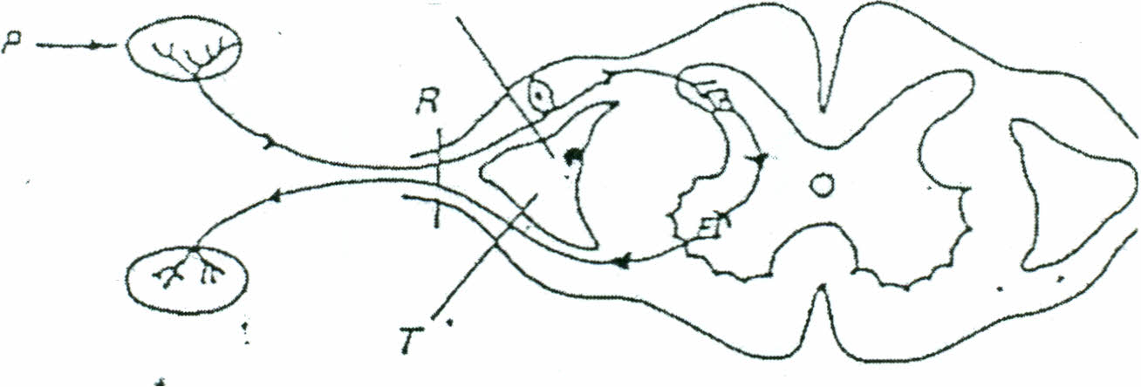

**P**

**Q**

|  |  |  |
| --- | --- | --- |
|  | **P** | **Q** |
| a) | Skin, glands | Muscle, sense organs |
| b) | Sense organs, skin | Glands, muscles |
| c) | Muscle, sense organs | Skin, glands |
| d) | Glands, muscle | Sense organs, skin |

1. The dendrite:
   1. takes a nerve impulse away from the cell body.
   2. takes an impulse towards the cell body.
   3. modulates the nerve impulse.
   4. insulates the nerve impulse.
2. The function of the cerebral cortex is:
   1. thinking and association.
   2. coordination of smooth muscle activity.
   3. control of the peripheral nervous system.
   4. control of autonomic nervous functions.
3. A ‘control’ in an experiment can be best described as:
   1. part of the experiment which is altered.
   2. the variable which is being measured.
   3. part of the experiment used to compare the experimental results to.
   4. the variable which is not altered.

Refer to the diagram below to answer questions 23 and 24.

**H**

**F**

**B**

**A**

**G**

**D**

**C**

**E**

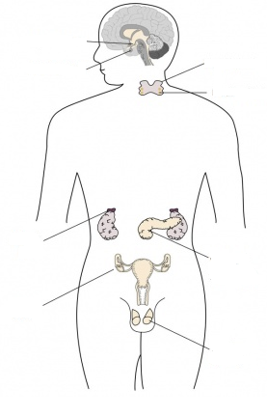

1. Which of the following glands controls the other endocrine glands of the body?
   1. B.
   2. C.
   3. D.
   4. E.
2. Which of the following glands produce sex hormones?
   1. B, C and D.
   2. B, E and G.
   3. E, C and D.
   4. C, D and H.
3. The part of the nervous system which includes the brain and spinal cord is:
   1. the central nervous system.
   2. the peripheral nervous system.
   3. the sympathetic nervous system.
   4. the parasympathetic nervous system.
4. When a nerve cell is at rest, there is a potential difference between the inside of the cell and the outside of about 70mV. This difference in charge exists because:
   1. the membrane continuously pumps positively charged potassium ions from the intracellular fluid to the extracellular fluid.
   2. the intracellular fluid has more negatively charged ions than the extracellular fluid.
   3. The extracellular fluid has more positive sodium ions than the intracellular fluid.
   4. sodium ions which are positively charged are more concentrated in the intracellular fluid.
5. Which of the following is the correct pathway of a ‘reflex arc’?
   1. Stimulus, sensory neuron, motor neuron, association neuron, receptor, effector.
   2. Stimulus, receptor, sensory neuron, association neuron, motor neuron, effector.
   3. Receptor, sensory neuron, motor neuron, association neuron, effector, stimulus.
   4. Receptor, sensory neuron, association neuron, motor neuron, effector, stimulus.
6. A nerve impulse would travel fastest along:
   1. a non-myelinated axon 30µm in diameter.
   2. a myelinated axon 25cm long and 15µm in diameter.
   3. a non-myelinated axon 15cm long.
   4. a myelinated axon 25cm long and 20µm in diameter.
7. Protein and amine hormones work by:
   1. attaching to receptor proteins in the extracellular fluid.
   2. attaching to receptor proteins in the membrane of the target cell.
   3. entering target cells and combining with a receptor protein inside the cell.
   4. entering target cells and combining with a receptor protein on the mitochondria.
8. The junction between the branches of adjacent neurons is called:
   1. a multipolar neuron.
   2. the synapse.
   3. an action potential.
   4. a refractory period.

Name: ________________________________

**Human Biology**

**ATAR Unit 3**

**Test 1**

**Scientific Method, Endocrine and Nervous Systems**

|  |  |  |
| --- | --- | --- |
| Part A:  Multiple Choice | 30 marks |  |
| Part B:  Vocabulary | 10 marks |  |
| Part C:  Short Answer | 55 marks |  |
| Part D:  Extended Answer | 10 marks |  |
| Total: | 105 marks |  |

**Human Biology**

**ATAR Unit 3**

**Test 1**

**Scientific Method, Endocrine and Nervous Systems**

Place a **X** through the best alternative for each question.

|  |  |  |  |  |  |  |  |  |  |  |
| --- | --- | --- | --- | --- | --- | --- | --- | --- | --- | --- |
| **1** | (a) | (b) | ( c) | (d) |  | **16** | (a) | (b) | ( c) | (d) |
| **2** | (a) | (b) | ( c) | (d) |  | **17** | (a) | (b) | ( c) | (d) |
| **3** | (a) | (b) | ( c) | (d) |  | **18** | (a) | (b) | ( c) | (d) |
| **4** | (a) | (b) | ( c) | (d) |  | **19** | (a) | (b) | ( c) | (d) |
| **5** | (a) | (b) | ( c) | (d) |  | **20** | (a) | (b) | ( c) | (d) |
| **6** | (a) | (b) | ( c) | (d) |  | **21** | (a) | (b) | ( c) | (d) |
| **7** | (a) | (b) | ( c) | (d) |  | **22** | (a) | (b) | ( c) | (d) |
| **8** | (a) | (b) | ( c) | (d) |  | **23** | (a) | (b) | ( c) | (d) |
| **9** | (a) | (b) | ( c) | (d) |  | **24** | (a) | (b) | ( c) | (d) |
| **10** | (a) | (b) | ( c) | (d) |  | **25** | (a) | (b) | ( c) | (d) |
| **11** | (a) | (b) | ( c) | (d) |  | **26** | (a) | (b) | ( c) | (d) |
| **12** | (a) | (b) | ( c) | (d) |  | **27** | (a) | (b) | ( c) | (d) |
| **13** | (a) | (b) | ( c) | (d) |  | **28** | (a) | (b) | ( c) | (d) |
| **14** | (a) | (b) | ( c) | (d) |  | **29** | (a) | (b) | ( c) | (d) |
| **15** | (a) | (b) | ( c) | (d) |  | **30** | (a) | (b) | ( c) | (d) |

**Part B: Vocabulary**

**Write the term to match the descriptions provided (10 Marks)**

|  |  |
| --- | --- |
| The part of the nervous system which excludes the brain and spinal cord. |  |
| An involuntary response to a stimulus often made unconsciously. |  |
| Structure where a nerve fibre meets a muscle fibre. |  |
| The portion of a neuron that carries impulses away from the cell body. |  |
| The fatty covering of a nerve fibre. |  |
| The membranes covering the brain and spinal cord. |  |
| Gland that secretes into a duct that carries the secretion to the surface of the body cavities. |  |
| A response preparing the body for increased activity. |  |
| Feedback that is the opposite of the original stimulus. |  |
| Type of hormone which enters cell and combines with receptor protein inside cell. |  |

**Part C: Short Answer**

**Write your answers in the spaces provided.**

1. Complete the table below relating to some of the effects of the Autonomic Nervous System.

|  |  |  |  |
| --- | --- | --- | --- |
| **Structure** | **Effect of Sympathetic Stimulation** | **Effect of Parasympathetic Stimulation** | |
| Heart |  |  |
| Liver |  |  |
| Sweat Glands |  |  |
| Pupils |  |  |

**(8 Marks)**

1. Complete the table below the diagram labelling the parts of a neuron.

C

B

D

E

A

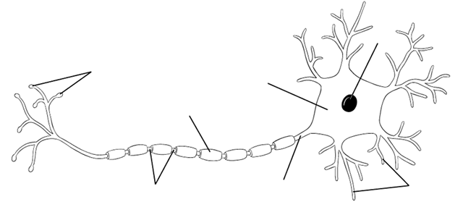

H

G

F

|  |  |
| --- | --- |
| **Label** | **Name** |
| A |  |
| B |  |
| C |  |
| D |  |
| E |  |
| F |  |
| G |  |
| H |  |

**(4 Marks)**

1. What is the function of the myelin sheath? ____________________________________________________________________________________________________________________________________________

**(1 Mark)**

1. For the brain diagram below give both the name of the part and its main function.

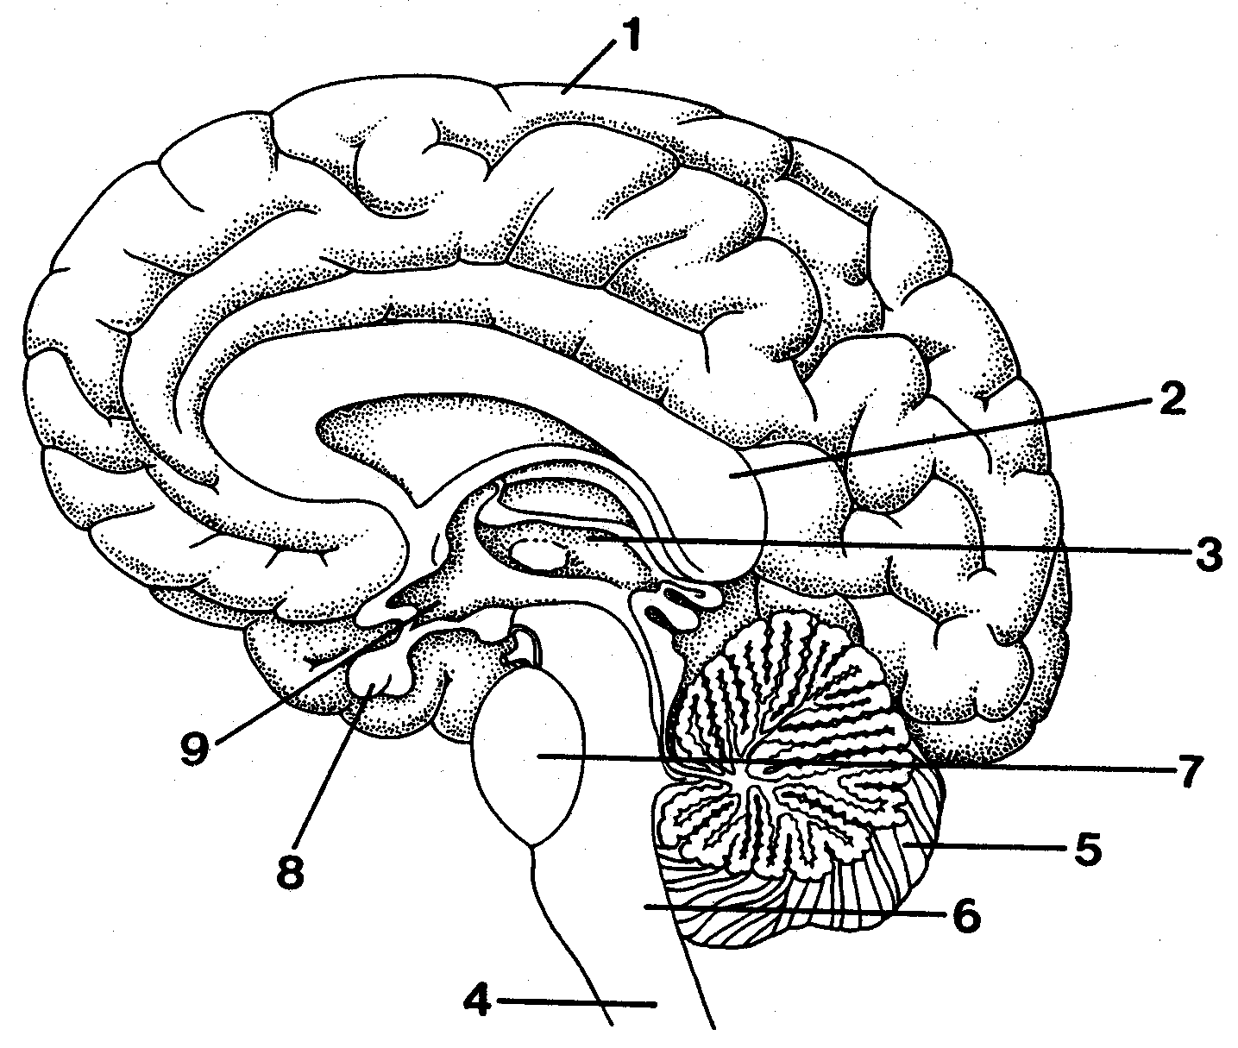

|  |  |  |
| --- | --- | --- |
| **Label** | **Name** | **Function** |
| 1 |  |  |
| 2 |  |  |
| 4 |  |  |
| 5 |  |  |
| 6 |  |  |
| 8 |  |  |
| 9 |  |  |

**(14 Marks)**

1. Explain why the posterior lobe of the pituitary gland is not considered to be a true endocrine gland.

____________________________________________________________________________________________________________________________________________

**(2 Marks)**

1. Define the following terms:

|  |  |
| --- | --- |
| **Term** | **Definition** |
| Polarised |  |
| All or none response |  |
| Saltatory  Conduction |  |
| Refractory  Period |  |

**(4 Marks)**

1. Describe how transmission occurs across a synapse.

__________________________________________________________________________________________________________________________________________________________________________________________________________________

**(3 Marks)**

1. Fill in the table below, contrasting the actions and effects of nerves and hormones.

|  |  |  |
| --- | --- | --- |
|  | **Nerve Impulses** | **Hormones** |
| **Speed** |  |  |
| **Transmission** |  |  |
| **Duration** |  |  |
| **Specificity** |  |  |

**(4 Marks)**

1. Identify two ways that hormones can exert their influence on a cell.

__________________________________________________________________________________________________________________________________________________________________________________________________________________

______________________________________________________________________ **(2 Marks)**

1. Complete the following table for the production, target and effect of the hormones listed. The first one has been done for you.

|  |  |  |  |
| --- | --- | --- | --- |
| **Hormone** | **Production site** | **Target cells/organ** | **Effect** |
| Prolactin | Anterior pituitary | Gland cells of the breast | Milk production |
| Growth hormone(GH) |  |  |  |
| Thyroid stimulating hormone (TSH) |  |  |  |
| Adrenocorticotrophic hormone (ACTH) |  |  |  |
| Follicle stimulating hormone (FSH) |  | Male:  Female: | Male:  Female: |
| Antidiuretic hormone (ADH) |  |  |  |
| Oxytocin  (OT) |  |  |  |

**(10 Marks)**

1. How are positive feedback control systems different to negative feedback?

______________________________________________________________________________________________________________________________________________________________________________________________________________________________________________________________________________________________________________________________________________________________

**(3 Marks)**

**Part D: Extended Answer (10 Marks)**

**This section contains one question. Write your answers on the paper provided.**

**Responses could include clearly labelled diagrams with explanatory notes; lists of points with linking sentences; clearly labelled tables and graphs and annotated flow diagrams with introductory notes.**

1. Describe how negative feedback is used to control the level of metabolism in the body. Use a flow diagram to illustrate your answer.